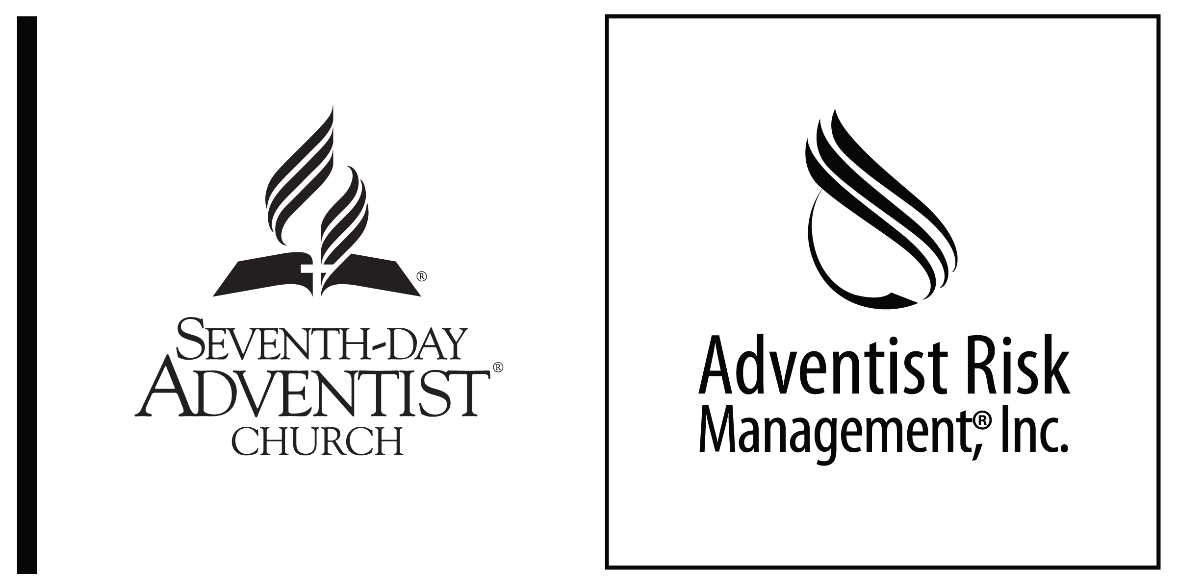
CHURCH/PARTICIPATION AGREEMENT
Seventh-day Adventist® Church

NOTE TO CONFERENCES — In reviewing whether a person should be allowed to participate in church services and other activities, the individual’s record and facts of the offense should be considered. Legal counsel in the jurisdiction should review the Participation Agreement to be sure it meets with all legal requirements of the jurisdiction and be suitable for the individual.

Church Attendance/Participation Agreement

I recognize that the ____________________________ Seventh-day Adventist® Church (hereafter “Seventh-day Adventist Church” or the “Church”) has a moral and legal responsibility to take reasonable steps to provide an environment of physical/emotional safety for its members so that they can worship and take part in church activities and less formal social contacts with church members without fear of inappropriate conduct or threat. I also recognize that of special concern is the protection for Minors (e.g. children and young people). The best interests of such Minors must be in the forefront of all considerations for anyone attending church services and other activities.
I further recognize that my attendance at the Seventh-day Adventist Church is a privilege extended to me to assist in meeting my spiritual needs. However, in doing so I understand that the following conditions are imposed for my attendance and I agree to abide by them because I am a Sexual Offender. Therefore, as a condition of my limited participation in this congregation, I agree to the following restrictions and conditions:

Definitions

Chaperone — a mature adult over the age of 30 years and of the same gender as the Participant and who is not a relative of the Participant. Further, a Chaperone must be approved by the Church Board or the Board of Elders. The Participant agrees that each Chaperone shall be given a copy of this Agreement, advised of its content and the appropriate protocols should concerns arise. The Chaperone(s) approved under this Agreement is named on Exhibit A hereto which is incorporated by reference. The Church reserves the right to change the name(s) of the Chaperone(s) at any time at its discretion.
Minor — any person who is under the age of majority in their jurisdiction including all children and young people regardless of whether such young person has indicated consent to any conduct.
Participant — the person who is a sexual offender who wishes to take part in church services and activities and agrees to be governed in his/her conduct under the terms of this Agreement.
Sexual Offender — any person who has been convicted of, admitted to, or is known by process of church discipline to have engaged in any unlawful sexual conduct or who has attempted, conspired, or solicited any sexual contact involving a minor.
Terms of Participation

I, the Participant undersigned, recognize the need to ensure a safe environment for the members of the Church and will fully cooperate with these efforts and agree to the following terms and conditions in order to allow my participation and attendance at activities sponsored by or associated with the Seventh-day Adventist Church:

- I understand that I may participate in worship in the sanctuary, the adult Sabbath School class of my choice and potluck. I agree to use the most direct route from the parking lot to the main entrance to these facilities and then to the activity location without passing through any other parts of the church buildings. Any deviation from this route will require prior authorization and accompaniment by one of my Chaperones.

- I will not associate with any Minors attending or participating in any church/school activity. I will not sit next to a Minor and if a Minor sits next to me, I will move.

- I will not linger in areas where Minors are being taught and will not go to any area where ministries for Minors are being conducted. If I need to be where Minors are meeting, I will only do so with a Church-appointed Chaperone.

- At no time will I place myself in or remain in any location in or around the Church facilities that would cause undue distress to others. (This prohibits me from being in or near preschool, children’s Sabbath School, youth or Pathfinder/Adventurer activities (both at the Church facility and during activities that are not on the Church property) or similar areas of the Church facilities.)

- I will under no circumstances take a child home with me or transport any child anywhere except in the case of an emergency and then only with another adult present at all times.

- I will not develop any special relationships with any Minor or their parents.

- I will not go to a church member’s home where a Minor is present, for any meals, Bible study, or get-togethers unless I have an approved Chaperone with me. I will not invite any Minor into my home as a visitor.

- If I have a family (spouse and child) who would normally attend church-sponsored functions for families, I will attend only my family but at no time will I leave the immediate proximity of my family or of one of my Chaperones

- I agree it is my responsibility to maintain an accountability network with individuals as defined by the Church and make sure my whereabouts at church or church activities is monitored by one of my Chaperones at all times.

- I agree to meet with the Board of Elders regarding the status of my adherence to this Agreement at any reasonable time requested.

- I authorize the Church to obtain information regarding me from my parole officer, governmental agencies or other persons who might have information relative to my prior criminal convictions.

- I agree to comply with any court-mandated restrictions, treatment, and/or requirements and recognize that these take precedence over any less restrictive parts of this Agreement.

- If I am on probation or parole, I will satisfactorily comply with and complete the terms of my probation or parole. I will provide the pastor with the name and contact information of my probation or parole officer. The pastor is free to contact my probation or parole officer and any violation of my probation or parole will be reported.
  - I understand and agree that the Church, in fulfilling its responsibilities to provide a safe environment for its members and guests, may find it necessary to disclose an account of my past behavior and/or criminal history to parents, church leaders, and other persons who may need to have such information in order to meet their parental or supervisory responsibilities. Accordingly, I hereby specifically authorize any member of the Seventh-day Adventist Church to announce, publish either verbally or in written form that I am a Sex Offender. I understand and agree that the level of detail in such a publication will be at the Seventh-day Adventist Church’s sole discretion. I hereby release the Seventh-day Adventist Church and its members from any and all liability of whatever kind, which may directly or indirectly result from any such publication.
  - Without limiting the forgoing, I specifically authorize the Church to notify the following church leaders that I am a Sex Offender:
    - Church Board members
    - Children’s Division Leaders
    - Pathfinder Director
    - Adventurer Director
    - Head Deacon and Assistants
    - Vacation Bible School leader
    - School Principal and teachers
    - School Board members
    - Children’s Ministries Coordinator

- I understand that the provisions of this Participation Agreement do not create any personal and/or legal rights against the Seventh-day Adventist Church or any other Seventh-day Adventist entity, member, volunteer, agent or employee that would afford me any claim or right of redress in any legal or administrative proceedings, nor does this agreement in any way preclude the Seventh-day Adventist Church or any other Seventh-day Adventist entity from exercising its right to freely exercise its faith as set forth in the United States Constitution and the Constitution of this State with respect to church governance in matters relating to conditions of church membership and/or discipline.

- I understand and accept that there will be an annual notification by the Church in a form determined by the Church informing our Church family that there is a Sex Offender who attends the church services, and referring those wishing additional information to the head elder or the pastor. I also authorize the notification of all members joining the church.

- I understand this Agreement may be reviewed every six months by the Church and will remain in effect as long as I am a member of or attend this Church. I will not request, seek access to, remove, or avail myself of any materials, files, directories, or rosters, or any other record listing children or minors in or associated with the congregation.

- The Seventh-day Adventist Church does not represent that the restrictions set forth in this Participation Agreement are a complete and exhaustive list as no document can foresee all possible issues. Accordingly, the Church reserves the right to place additional conditions/restrictions on me as the need may, in the Church’s sole discretion, arise from time to time.

- I have read and understand the above conditions and agree to abide by them. If at any point I fail to adhere to any of the above conditions, I recognize that my participation at the Seventh-day Adventist Church may be terminated or otherwise restricted. Such determination of failure on my part and setting additional restrictions to include terminating my right of participation in any church activities shall be at the sole discretion of the Seventh-day Adventist Church board.

- This Agreement shall remain valid as long as I attend and/or participate in the activities of the Church named in this document, and should I wish to transfer my attendance, participation, or membership to another Seventh-day Adventist Church, a copy of this document will be sent to that Church.

I have read and understand the above conditions and agree to abide by them.

Dated this ________ day of _____________________, 20____.

_____________________________________ __________________________________
Participant’s Signature Participant’s Printed Name

_____________________________________ __________________________________
Name of Local Church Signature of Local Church Official

